Camera Features of IMX477 and Related Commands For Display

1:57:36.349320513] [7019] INFO Camera camera_manager.cpp:327 libcamera v0.4.0+50-83cb8101
[1:57:36.358425924] [7022] INFO RPI pisp.cpp:720 libpisp version v1.1.0 e7974a156008 27-01-2025 (21:50:51)
[1:57:36.387265113] [7022] INFO RPI pisp.cpp:1179 Registered camera /base/axi/pcie@120000/rp1/i2c@80000/imx477@1a to CFE device /dev/media1 and ISP device /dev/media0 using PiSP variant BCM2712_D0
Preview window unavailable
Mode selection for 2028:1520:12:P
SRGGB10_CSI2P,1332x990/0 - Score: 3456.22
SRGGB12_CSI2P,2028x1080/0 - Score: 1083.84
SRGGB12_CSI2P,2028x1520/0 - Score: 0
SRGGB12_CSI2P,4056x3040/0 - Score: 887
Stream configuration adjusted
[1:57:36.388066980] [7019] INFO Camera camera.cpp:1202 configuring streams: (0) 2028x1520-YUV420 (1) 2028x1520-BGGR_PISP_COMP1
[1:57:36.388152387] [7022] INFO RPI pisp.cpp:1484 Sensor: /base/axi/pcie@120000/rp1/i2c@80000/imx477@1a - Selected sensor format: 2028x1520-SBGGR12_1X12 - Selected CFE format: 2028x1520-PC1B
#0 (0.00 fps) exp 32987.00 ag 4.36 dg 1.16
#1 (30.01 fps) exp 32987.00 ag 4.36 dg 1.16
#2 (30.01 fps) exp 32987.00 ag 5.02 dg 1.00
#3 (30.01 fps) exp 32987.00 ag 5.02 dg 1.00
#4 (30.01 fps) exp 32987.00 ag 5.02 dg 1.00
#5 (30.01 fps) exp 32987.00 ag 5.02 dg 1.00
#6 (30.01 fps) exp 32987.00 ag 5.07 dg 1.00
#7 (30.01 fps) exp 32987.00 ag 5.07 dg 1.00
#8 (30.01 fps) exp 32987.00 ag 5.07 dg 1.00
#9 (30.01 fps) exp 32987.00 ag 5.07 dg 1.00
#10 (30.01 fps) exp 32987.00 ag 5.07 dg 1.00
#11 (30.01 fps) exp 32987.00 ag 5.07 dg 1.00
#12 (30.01 fps) exp 32987.00 ag 5.07 dg 1.00
#13 (30.01 fps) exp 32987.00 ag 5.07 dg 1.00
#14 (30.01 fps) exp 32987.00 ag 5.07 dg 1.00
#15 (30.01 fps) exp 32987.00 ag 5.07 dg 1.00
#16 (30.01 fps) exp 32987.00 ag 5.07 dg 1.00
#17 (30.01 fps) exp 32987.00 ag 5.07 dg 1.00
#18 (30.01 fps) exp 32987.00 ag 5.07 dg 1.00
#19 (30.01 fps) exp 32987.00 ag 5.07 dg 1.00
#20 (30.01 fps) exp 32987.00 ag 5.07 dg 1.00
#21 (30.01 fps) exp 32987.00 ag 5.07 dg 1.00
#22 (30.01 fps) exp 32987.00 ag 5.07 dg 1.00
#23 (30.01 fps) exp 32987.00 ag 5.07 dg 1.00
#24 (30.01 fps) exp 32987.00 ag 5.07 dg 1.00
#25 (30.01 fps) exp 32987.00 ag 5.07 dg 1.00
#26 (30.01 fps) exp 32987.00 ag 5.07 dg 1.00
#27 (30.01 fps) exp 32987.00 ag 5.07 dg 1.00
#28 (30.01 fps) exp 32987.00 ag 5.07 dg 1.00
#29 (30.01 fps) exp 32987.00 ag 5.07 dg 1.00
#30 (30.01 fps) exp 32987.00 ag 5.07 dg 1.00
#31 (30.01 fps) exp 32987.00 ag 5.07 dg 1.00
#32 (30.01 fps) exp 32987.00 ag 5.07 dg 1.00
#33 (30.01 fps) exp 32987.00 ag 5.07 dg 1.00
#34 (30.01 fps) exp 32987.00 ag 5.07 dg 1.00
#35 (30.01 fps) exp 32987.00 ag 5.07 dg 1.00
#36 (30.02 fps) exp 32987.00 ag 5.07 dg 1.00
#37 (30.01 fps) exp 32987.00 ag 5.07 dg 1.00
#38 (30.01 fps) exp 32987.00 ag 5.07 dg 1.00
#39 (30.01 fps) exp 32987.00 ag 5.07 dg 1.00
#40 (30.01 fps) exp 32987.00 ag 5.07 dg 1.00
#41 (30.01 fps) exp 32987.00 ag 5.07 dg 1.00
#42 (30.01 fps) exp 32987.00 ag 5.07 dg 1.00
#43 (30.01 fps) exp 32987.00 ag 5.07 dg 1.00
#44 (30.01 fps) exp 32987.00 ag 5.07 dg 1.00
#45 (30.01 fps) exp 32987.00 ag 5.07 dg 1.00
#46 (30.01 fps) exp 32987.00 ag 5.07 dg 1.00
#47 (30.01 fps) exp 32987.00 ag 5.07 dg 1.00
#48 (30.01 fps) exp 32987.00 ag 5.07 dg 1.00
#49 (30.01 fps) exp 32987.00 ag 5.07 dg 1.00
#50 (30.01 fps) exp 32987.00 ag 5.07 dg 1.00
#51 (30.01 fps) exp 32987.00 ag 5.07 dg 1.00
#52 (30.01 fps) exp 32987.00 ag 5.07 dg 1.00
#53 (30.01 fps) exp 32987.00 ag 5.07 dg 1.00
#54 (30.01 fps) exp 32987.00 ag 5.07 dg 1.00
#55 (30.01 fps) exp 32987.00 ag 5.07 dg 1.00
#56 (30.01 fps) exp 32987.00 ag 5.07 dg 1.00
#57 (30.01 fps) exp 32987.00 ag 5.07 dg 1.00
#58 (30.01 fps) exp 32987.00 ag 5.07 dg 1.00
#59 (30.01 fps) exp 32987.00 ag 5.07 dg 1.00
#60 (30.01 fps) exp 32987.00 ag 5.07 dg 1.00
#61 (30.01 fps) exp 32987.00 ag 5.07 dg 1.00
#62 (30.01 fps) exp 32987.00 ag 5.07 dg 1.00
#63 (30.01 fps) exp 32987.00 ag 5.07 dg 1.00
#64 (30.01 fps) exp 32987.00 ag 5.07 dg 1.00
#65 (30.01 fps) exp 32987.00 ag 5.07 dg 1.00
#66 (30.01 fps) exp 32987.00 ag 5.07 dg 1.00
#67 (30.01 fps) exp 32987.00 ag 5.07 dg 1.00
#68 (30.01 fps) exp 32987.00 ag 5.07 dg 1.00
#69 (30.01 fps) exp 32987.00 ag 5.07 dg 1.00
#70 (30.01 fps) exp 32987.00 ag 5.07 dg 1.00
#71 (30.01 fps) exp 32987.00 ag 5.07 dg 1.00
#72 (30.01 fps) exp 32987.00 ag 5.07 dg 1.00
#73 (30.01 fps) exp 32987.00 ag 5.07 dg 1.00
#74 (30.01 fps) exp 32987.00 ag 5.07 dg 1.00
#75 (30.01 fps) exp 32987.00 ag 5.07 dg 1.00
#76 (30.01 fps) exp 32987.00 ag 5.07 dg 1.00
#77 (30.01 fps) exp 32987.00 ag 5.07 dg 1.00
#78 (30.01 fps) exp 32987.00 ag 5.07 dg 1.00
#79 (30.01 fps) exp 32987.00 ag 5.07 dg 1.00
#80 (30.01 fps) exp 32987.00 ag 5.07 dg 1.00
#81 (30.01 fps) exp 32987.00 ag 5.07 dg 1.00
#82 (30.01 fps) exp 32987.00 ag 5.07 dg 1.00
#83 (30.01 fps) exp 32987.00 ag 5.07 dg 1.00
#84 (30.01 fps) exp 32987.00 ag 5.07 dg 1.00
#85 (30.01 fps) exp 32987.00 ag 5.07 dg 1.00
#86 (30.01 fps) exp 32987.00 ag 5.07 dg 1.00
#87 (30.01 fps) exp 32987.00 ag 5.07 dg 1.00
#88 (30.01 fps) exp 32987.00 ag 5.07 dg 1.00
#89 (30.01 fps) exp 32987.00 ag 5.07 dg 1.00
#90 (30.01 fps) exp 32987.00 ag 5.07 dg 1.00
#91 (30.01 fps) exp 32987.00 ag 5.07 dg 1.00
#92 (30.01 fps) exp 32987.00 ag 5.07 dg 1.00
#93 (30.01 fps) exp 32987.00 ag 5.07 dg 1.00
#94 (30.01 fps) exp 32987.00 ag 5.07 dg 1.00
#95 (30.01 fps) exp 32987.00 ag 5.07 dg 1.00
#96 (30.01 fps) exp 32987.00 ag 5.07 dg 1.00
#97 (30.01 fps) exp 32987.00 ag 5.07 dg 1.00
#98 (30.01 fps) exp 32987.00 ag 5.07 dg 1.00
#99 (30.01 fps) exp 32987.00 ag 5.07 dg 1.00
#100 (30.01 fps) exp 32987.00 ag 5.07 dg 1.00
#101 (30.01 fps) exp 32987.00 ag 5.07 dg 1.00
#102 (30.01 fps) exp 32987.00 ag 5.07 dg 1.00
#103 (30.01 fps) exp 32987.00 ag 5.07 dg 1.00
#104 (30.01 fps) exp 32987.00 ag 5.07 dg 1.00
#105 (30.01 fps) exp 32987.00 ag 5.07 dg 1.00
#106 (30.01 fps) exp 32987.00 ag 5.07 dg 1.00
#107 (30.01 fps) exp 32987.00 ag 5.07 dg 1.00
#108 (30.01 fps) exp 32987.00 ag 5.07 dg 1.00
#109 (30.01 fps) exp 32987.00 ag 5.07 dg 1.00

2️⃣ Available Camera Modes & Resolution Selection

Mode selection for 2028:1520:12:P
SRGGB10_CSI2P,1332x990/0 - Score: 3456.22
SRGGB12_CSI2P,2028x1080/0 - Score: 1083.84
SRGGB12_CSI2P,2028x1520/0 - Score: 0
SRGGB12_CSI2P,4056x3040/0 - Score: 887

✔️ The sensor supports different resolutions and bit depths (10-bit or 12-bit Bayer formats).
✔️ Lower score = better mode (so 2028x1520 was cexposure hosen).
[1:57:36.388066980] [7019] INFO Camera camera.cpp:1202 configuring streams: (0) 2028x1520-YUV420 (1) 2028x1520-BGGR_PISP_COMP1
✔️ Selected image format:
- YUV420 → Standard color format for video streaming.
- BGGR_PISP_COMP1 → Raw Bayer format for further processing.

3️⃣ Sensor Format & Selected Configuration
[1:57:36.388152387] [7022] INFO RPI pisp.cpp:1484 Sensor: /base/axi/pcie@120000/rp1/i2c@80000/imx477@1a
- Selected sensor format: 2028x1520-SBGGR12_1X12
- Selected CFE format: 2028x1520-PC1B

✔️ Sensor Format:
- SBGGR12_1X12 → 12-bit Bayer pattern (BGGR).
✔️ CFE Format:
- PC1B → Compressed format optimized for Pi Image Signal Processor.

4️⃣ Camera Exposure & Gain Settings Over Time
#0 (0.00 fps) exp 32987.00 ag 4.36 dg 1.16
#1 (30.01 fps) exp 32987.00 ag 4.36 dg 1.16
#2 (30.01 fps) exp 32987.00 ag 5.02 dg 1.00
...
#109 (30.01 fps) exp 32987.00 ag 5.07 dg 1.00

- Frame Rate: 30 FPS (frames per second) is maintained.
- Exposure (exp): 32,987 microseconds (≈ 33ms) – Controls how long the sensor is exposed to light.
- Analog Gain (ag): Increases from 4.36 to 5.07 – This controls the sensor’s amplification before digital processing.
- Digital Gain (dg): Mostly remains 1.00 – Additional amplification after the image is read from the sensor.

SUMMARY AS A TABLE
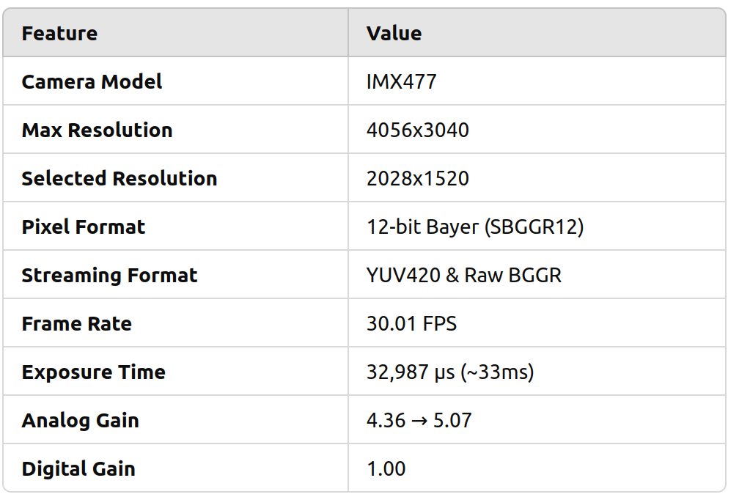
2️⃣The selected resolution is 2028x1520 with a 12-bit Bayer format.
3️⃣ Exposure and gain values are automatically adjusting for brightness.
4️⃣ Frame rate is steady at 30 FPS, meaning the camera is functioning smoothly.

